Assignment Brief: COMP2411 Systems Analysis & Design 2025-26, Across Semesters

Assignment 2 | Group Project
Word Limit or equivalent (e.g. time) | 3000 words (equivalent)
Weighting | 50%
Learning Outcomes Assessed | - Examine the professional, legal, ethical and social criteria and practices that constitute recognised and defendable good practice in an industrial or business setting.  - Evaluate and reflect on the product, development approach, risks, techniques, project management, performance and organisational change aspects of the project.  - Communicate project plans, produce project components, and organise, direct and manage a project using available support and testing tools.
Submission date | Friday May 1st 2026 by 3pm
Feedback date | All assignment feedback will be issued on the 20th working day following the submission deadline. Feedback will be released on: Monday June 1st 2026
Module Leader | Peter Clews
Verified by | Dr Eya Meddeb

If anything about this assignment is not clear to you, please contact your module leader.
What do I need to do to make a success of this assignment? | This project requires you to work in a group.  - Produce a project initiation document, requirements, systems analysis modelling and project management/planning documentation (Learning outcome 6).  During the seminars in week beginning 9th February 2026 you will need to communicate your project plan to the tutors in the form of a presentation (Learning outcome 6).  This part of the assignment is group work.  You will be able to receive formative feedback on this part of the assignment. You will get feedback in later weeks to inform your work.  - Put together a systems design, process specification, prototype, carry out testing and showcase your prototype and how it has met the requirements (Learning outcome 6).  This part of the assignment is group work.  You should submit only one copy of your group work documentation and prototype for parts 1 and 2 of assignment 2 where member names and student numbers are clearly recorded. You are required to keep a copy of work handed in. Note: It must be submitted with only one Student Feedback Form which clearly notes all team members’ names and student numbers, and the name of the marking tutor.  Write a critical evaluation and reflective learning journal (Learning outcomes 4 and 5). This part of the assignment must be completed and submitted individually.  - Your group should attend the showcase to present your prototype on Wednesday 6th May 2026. Times will be given closer to the event.

How should I present my work? | Please use the template below for part 1 and 2  On the title page list the following  Module name and code  Student numbers  Submission date  Assignment Number/Title  Part 1 (Group work)  Project Initiation document (700 words)  Project proposal (main written contents of A2 form)  Team Roles and Responsibilities (major and minor roles)  Project Aims (a general statement of purpose of intention, wording often starts ‘To….(do something)’.  Project Scope  Scope is a statement that defines the boundaries of the project – what will be done and also what will not be done.  (Takes the five ‘W’s into consideration – who, what, why, when, where. For example who are the stakeholders (e.g. people involved in your system)).  Project Risks (use risk log template – see Assessment folder in Blackboard)  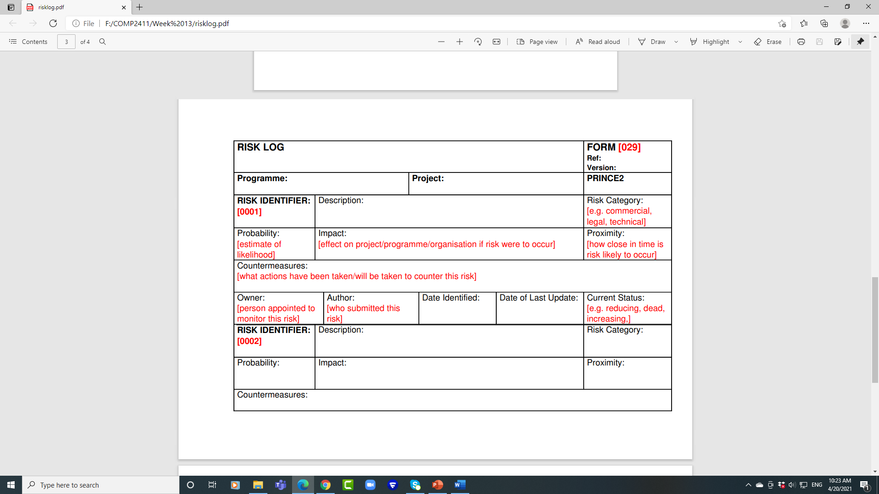  Reasons for the systems analysis and design approach/methodology selected  e.g. agile/plan-driven/structured/object-oriented.  (Include a few up-to-date academic references)  Requirements (900 words)  Functional requirements (number the functional requirements)  Non-functional requirements (Use non-functional requirements checklist subheadings – see Assessment folder)  - Use MoSCoW for requirements  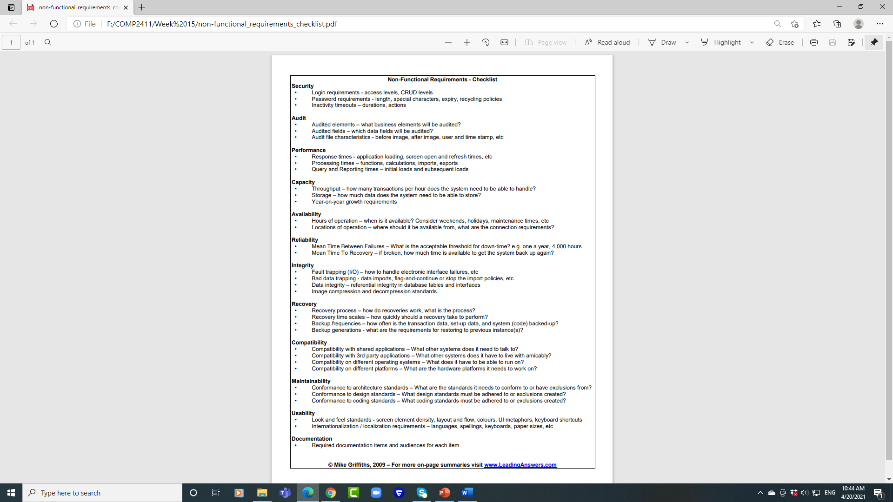  Systems analysis modelling (300 words equivalent)  - Model the functional requirements using at least one type of analysis model. Use either a structured technique (e.g. data flow diagram) or an object-oriented technique (e.g. Use Case diagram, analysis class diagram) or a combination of both.  - Assumptions (something that you assume to be the case/supporting explanations)  - Data Flow Diagrams - Include at least a context diagram and level 1. Further understanding can be shown through level 2 diagrams.  - Entity Relationship Diagrams - Include primary and foreign keys and relationship names. Attributes, data types and lengths can be included for the data dictionary.  - Use Case diagram - include the written Use Case  Project management/planning documentation (500 words equivalent)  - Minutes of meetings  (i.e. for each meeting - who has attended?; what have you discussed?; what decisions  have been made?; is there anything to be actioned?)  - Project plans (Gantt, Critical Path or Kanban)  For the whole group project and each group member. Also include any revisions made to the project plans.  - Conflict resolution, communication and teamwork details  Part 2 (Group work)  Systems design (400 words equivalent)  - Using appropriate techniques design a solution for the system. Ensure you include at least two design models  - For Games design modelling – design class diagram, sequence diagram, state transition.  - Assumptions  Process specification (600 words equivalent)  - Program flow/activity diagram  - Structure chart of the system’s menu  - User interface designs with pseudocode  (for three of the interface screens)  - Assumptions  Testing (800 words)  - Include the test plans, results, screenshots and address the problems encountered.  - Black box testing  Simple Test Plan Example  Test No Test Data Expected result Actual Result Comment  - White box testing  Simple Test Plan Example  Object Name Location Purpose Expected Actual Action Date  Presentation will be in class at a showcase event.  Write approx. 300 words evaluation to explain how closely the actual system meets the original aims/objectives of the project.  Only ONE video and ONE 300 word evaluation per team is needed.  NOTE  If one or more of your team members has been unable to collaborate fully on the project due to illness or for any other reason - let the module leader know. That person will have to follow the current university guidelines for mitigating circumstances and submitting the reassessment.  Please use the template below for part 3  On the title page list the following  Module name and code  Student numbers  Submission date  Assignment Number/Title  Part 3 (Individual submission)  Critical evaluation (750 words)  A critical evaluation of the following:  - Performance of the prototype  - Level of conformance of the prototype to the requirements  - Development approach  - Risks  - Project and change management  - Professional, legal, ethical and social aspects that were taken into consideration for the  project  Reflective learning journal  - Critical reflection of two other Systems group projects.  - Student names/group names and project titles  - Critical reflection on the pros and cons of 2 of the projects  (250 words)  - Evaluation of own participation and other team members in the project for this module  (200 words)  - Matrix of group performance  Other Group Members Names A B C D E F G H NS  ………………………………  ………………………………  ………………………………  ………………………………  References (use the University Harvard referencing system, support is available through the library www.worc.ac.uk/library/guides/study-skills/referencing)

How can I obtain guidance on my assignment? | The assessment briefing will take place during the first week of both semesters. During this session, students will receive detailed information about the assessment criteria, expectations, and guidelines. It is crucial for all students to attend this briefing to ensure they understand the requirements and can ask any questions they may have.  You can submit an assessment plan of your work in progress to enable you to obtain guidance on the overall structure and direction of your assignment. You should submit this by Friday 6th March 2026 to enable you to review and address feedback provided to develop your work.  There are also feed-forward opportunities on on a continuous weekly basis for you to receive feedback/guidance* to enhance your assessment. Participation is highly recommended as it offers valuable insights and guidance from the tutors.

How and when do I hand my assignment in? | Your work must be word-processed/typed and should clearly show your student number. You should submit your work by the 3pm deadline on Friday May 1st 2026. You should submit your work to Blackboard which is available via MyDay.  You are required to keep a copy of work handed in.  See the separate Assignment Support Information document on Blackboard for help on how to submit or what to do if you are having trouble submitting your assignment.

How will my assignment be marked? | Specific marking criteria for your assignment is provided in the Grading Matrix within this document.  You are strongly advised to check your completed work against the Grading Matrix to ensure have completed all areas required before you submit it.  You should also ensure you adhere to the word limit / word count stated in your assessment brief document, details of which can be found in the University’s Assessment Policy

Use of Generative Artificial Intelligence  (Gen AI) | We are aware of the benefits that the responsible use of Generative Artificial Intelligence (GenAI) tools can bring, however, where it is deemed that there has been inappropriate or unethical use of GenAI to generate assignments either wholly or in part, this is classed as academic misconduct and will result in academic misconduct proceedings being brought. Use of Generative AI must be expressly permitted by your module leader. *Please refer to the library services Artificial Intelligence webpage for information about what is classed as ethical and appropriate use of AI.  Generative AI can be used to assist with the development of your prototype ONLY and must be acknowledged.  The use of AI to produce any part of your documentation is prohibited and may result in referral to the Academic Integrity Tutor.  If you’re unsure and want some advice, please contact your module tutor, module leader or personal academic tutor for guidance.

Grading Matrix
This matrix captures the assessment criteria for this part of the coursework.

Student Name/Number: |  | Assignment No: | 002 | Weighting: | 50%
Module Code: | COMP2411 | Assignment Title: | Group Project
Module Title: | Systems Analysis & Design | Semester: | 2
Learning Outcomes being assessed:
- Examine the professional, legal, ethical and social criteria and practices that constitute recognised and defendable good practice in an industrial or business setting.
- Evaluate and reflect on the product, development approach, risks, techniques, project management, performance and organisational change aspects of the project.
- Communicate project plans, produce project components, and organise, direct and manage a project using available support and testing tools.

Assessment Criteria

GRADE | Problem understanding. Project management. Requirements.  (20%) | Modelling and design  (20%) | Performance of the prototype  (15%) | Testing  (10%) | Individual participation, critical evaluation and reflection  (30%) | Professionalism, presentation, and SPAG  (5%)
A | Demonstrates an excellent ability in: understanding the problem domain/topic under investigation; identification of risks; defines the aims, scope and completion of the project proposal documentation; allocation of team members with roles and responsibilities and discussion of a methodology/approach to the project.  Demonstrates an excellent level of coverage and evidence in comprehensive functional and non-functional requirements | Appropriate analysis modelling techniques chosen and used, with supporting explanations/assumptions shown where needed and modelling conventions followed. Case study taken into consideration fully.  Appropriate design modelling/process specification techniques chosen and used, with supporting explanations/assumptions shown where needed and modelling conventions followed. Case study taken into consideration fully. | Demonstrates an excellent ability in the prototype’s level of performance and conformance to the requirements | Demonstrates an excellent level of completeness and evidence in test plans, results, and addressing the problems encountered | Demonstrates an excellent level of  coverage & evidence in: issues concerning development such as the process, the project and prototype performance, legal and professional aspects, and degree of conformance to the requirements.  Demonstrates an excellent level of effectiveness and evidence in critical reflection and participation evaluation | Demonstrates excellent communication of project plans.  Excellent use of appropriate presentation tools and techniques.  Demonstrates excellent skills in team interaction and dynamics. Fully engaged with all aspects of the project and assigned roles.  Spelling, punctuation, and grammar are perfect.
B | Demonstrates a good ability in: understanding the problem domain/topic under investigation; identification of risks; defines the aims, scope and completion of the project proposal documentation; allocation of team members with roles and responsibilities and discussion of a methodology/approach to the project.  Demonstrates a good level of coverage and evidence in functional and non-functional requirements | Most of the above elements covered with minor omissions or errors.  Most of the above elements covered with minor omissions or errors. | Demonstrates a good ability in the prototype’s level of performance and conformance to the requirements | Demonstrates a good level of completeness and evidence in test plans, results, and addressing the problems encountered | Demonstrates a good level of  coverage & evidence in: issues concerning development such as the process, the project and prototype performance, legal and professional aspects, and degree of conformance to the requirements.  Demonstrates a good level of effectiveness and evidence in critical reflection and participation evaluation. | Demonstrates good skills in communication of project plans.  Effective use of appropriate presentation tools and techniques.  Demonstrates good skills in team interaction and dynamics. Fully engaged with all aspects of the project and assigned roles.  Spelling, punctuation, and grammar contain very minor errors.
C | Demonstrates a sufficiently average ability in: understanding some of the problem domain/topic under investigation; identification of risks; define the aims, scope and complete the project proposal documentation; allocation of team members with roles and responsibilities and definition of a methodology/approach to the project  Demonstrates sufficiently average level of coverage and evidence in most of the functional and non-functional requirements | Analysis modelling techniques used, with some satisfactory supporting explanations/assumptions. Modelling conventions followed but with some errors. Some of the case study taken into consideration.  Design modelling/process specification techniques used, with some satisfactory supporting explanations/assumptions. Modelling conventions followed but with some errors. Some of the case study taken into consideration. | Demonstrates sufficiently average ability in the prototype’s level of performance and conformance to the requirements | Demonstrates sufficiently average completeness and evidence in: test plans, results, and addressing the problems encountered | Demonstrates sufficiently average level of coverage and evidence in:  issues concerning development such as the process, the project and prototype performance, legal and professional aspects, and degree of conformance to the requirements.  Demonstrates sufficiently average effectiveness & evidence in critical reflection and participation evaluation | Demonstrates sufficiently average skills in communicating project plans.  Sufficiently average use of appropriate presentation tools and techniques.  Demonstrates sufficient skills in team interaction and dynamics. Mostly engaged with all aspects of the project and assigned roles.  Spelling, punctuation, and grammar contain several minor errors
D | Demonstrates a fair ability in the following: understanding some of the problem domain/topic under investigation; identification of some risks; defines the aims, scope and completion of project proposal documentation; allocation of team members with roles and responsibilities and definition of a methodology/approach to the project  Demonstrates a fair level of coverage and evidence in: functional and non-functional requirements, with some elements missing/inappropriate | Analysis modelling techniques used, with weak or no supporting explanations/assumptions shown. A number of errors with modelling conventions. Case study not fully taken into consideration.  Design modelling/process specification techniques used, with weak or no supporting explanations/assumptions shown. A number of errors with modelling conventions. Case study not fully taken into consideration. | Demonstrates a fair ability in the prototype’s level of performance and conformance to the requirements | Demonstrates a fair completeness and evidence in: test plans, results, and addressing the problems encountered | Demonstrates fair level of coverage and evidence in:  issues concerning development such as the process, the project and prototype performance, legal and professional aspects, and degree of conformance to the requirements.  Demonstrates fair effectiveness and evidence in critical reflection and participation evaluation. | Demonstrates fair skills in communicating project plans.  Use of presentation tools and techniques.  Demonstrates fair skills in team interaction and dynamics. Some engagement with all aspects of the project and assigned roles.  Spelling, punctuation, and grammar contain several errors
E-F | Weak/poor attempt in general with parts missing.  Inappropriate/poorly written requirements for the chosen project. | Poor analysis modelling techniques chosen and used, with no supporting explanations/assumptions given and modelling conventions not followed. Case study poorly taken into consideration.  Inappropriate/poor design modelling/process specification techniques chosen and used, with poor supporting explanations/assumptions given and modelling conventions poorly followed. Case study poorly taken into consideration. | Weak/poor attempt in general | Weak/poor  attempt in general | Weak/Poor attempt in general | Weak/poor attempt in general.  Very limited evidence of team interaction and dynamics. Very limited engagement with the project and assigned roles.  Spelling, punctuation, and grammar errors make the documentation challenging to read.
G | No allocation of team members and roles and responsibilities;  proposal and understanding the problem domain/topic under investigation not completed;  project aims and scope of chosen project with respect to team skills not completed;  risks not identification;  No choice of methodologies/approach.  No requirements for the case study. | No analysis modelling.  Project not taken into consideration.  No design modelling/process specification techniques chosen and used.  No supporting explanations/assumptions given and modelling conventions not followed. Case study not taken into consideration. | Prototype does not conform to requirements/has not been developed. | No test plans, results, and addressing the problems encountered. | No issues concerning development such as the process, the project and prototype performance, legal and professional aspects, and degree of conformance to the requirements.  No demonstration of effectiveness and evidence in critical reflection and participation evaluation | No communication of project plans.  No use of appropriate presentation tools and techniques.  No team interaction and dynamics demonstrated. No attempt to engage with the project and assigned roles.  Spelling, punctuation, and grammar errors make the documentation unreadable.
H / NS | Seriously inadequate or insufficient response or non-submission. | Seriously inadequate or insufficient response or non-submission. | Seriously inadequate or insufficient response or non-submission. | Seriously inadequate or insufficient response or non-submission. | Seriously inadequate or insufficient response or non-submission. | Seriously inadequate or insufficient response or non-submission.

NB: RESULTS ARE PROVISIONAL UNTIL AGREED BY THE BOARD OF EXAMINERS

